**ELECTRIC RATES TRAINING**

**ELECTRICITY GRID BASICS**

The U.S. electricity grid consists of three basic elements: generation, transmission and distribution. <http://www.nerc.com/page.php?cid=1%7C15>, <http://www.youtube.com/user/pjminterconnection>

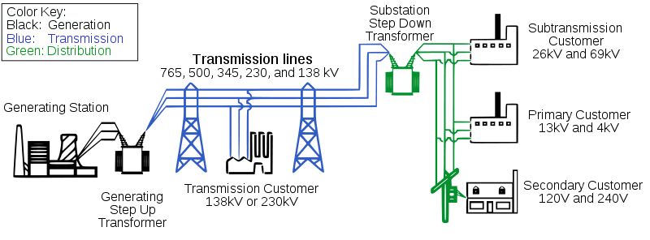

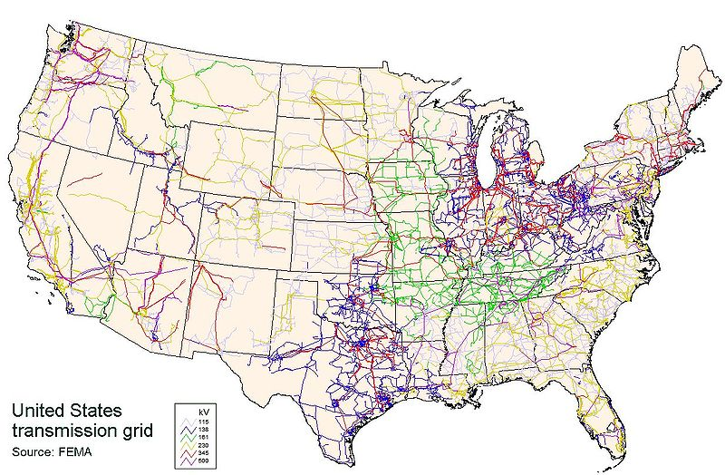

**GENERATION**

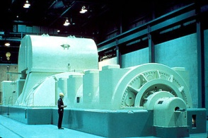The generation element of the electricity grid produces electricity that is transmitted and distributed to customers. An electrical generator converts mechanical energy into electrical energy. Coal, natural gas and nuclear are the primary fuels used in the United States for generating electricity. Oil, hydro, solar and other fuels such as biomass are also being used. Dominion purchases approximately 29% of its generation. Dominion has said that Virginia imports more energy than any other state except for California which is approximately 25 percent of its power.

The cost of fuel is quickly becoming one the largest components of an electricity bill. In Virginia, the State Corporation Commission (SCC) sets the fuel rate for Dominion Virginia Power after receiving a rate notice from Dominion. The fuel costs are passed along to the customer dollar for dollar through Fuel Charge Rider A which increased from $0.02803 per kilowatt-hour (kWh) to $0.03289 for Dominion’s Virginia Jurisdictional customers on 1 July 2011.

**TRANSMISSION**

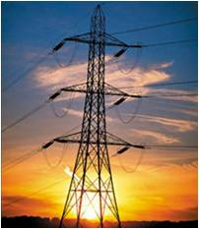The transmission element of the electricity grid transports the electricity at high voltages to distribution substations where the electricity is transformed to a lower voltage for distribution to customers. Some large industrial customers do accept electricity at the transmission voltage level. Within the Dominion Virginia Power service territory, transmission voltages are 69 kV, 110 kV, 230 kV and 500 kV. Projects to build new transmission lines are very expensive. The company's total investment in transmission facilities more than doubled from 2008 to 2011, rising from about $980 million to about $2.25 billion. Customers pay for these new projects through Rider T – Transmission.

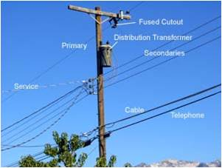**DISTRIBUTION**

The distribution element of the electricity grid distributes electricity from the transmission substations to the customers. Typical distribution voltages used by Dominion Virginia Power are 13.2 kV and 34.5 kV. The distribution electricity is usually distributed in wire overhead on a wooden pole or buried underground.

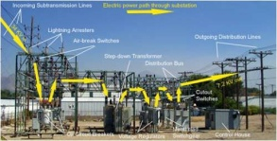

Distribution Substation

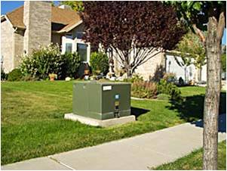

Residential pad mounted transformer for underground distribution line

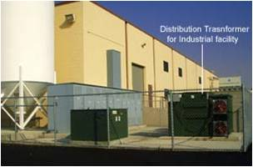

Distribution transformer for industrial facility.

**METERING**

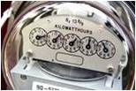Electric meters are used to measure consumption of electricity by customers. A watt-hour meter is calibrated in kilowatt-hours. One kilowatt-hour is the amount of electric energy required to provide 1,000 watts of power for a period of one hour. Ten 100-watt light bulbs left on for one hour consume one kilowatt-hour of electric energy. Analog meters have five dials.

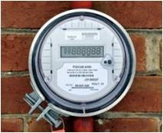Digital meters have digital readouts. The meter automatically scrolls through several different displays. Each display remains on screen for three to five seconds. These displays will show your kilowatt-hour usage, date and time and other network and diagnostic information.

Dominion reads their meters Monday – Friday each week. There are two Saturday reads scheduled for 2011. They publish a metering reading schedule annually. A copy of this schedule is in your notebook under the “Handouts” tab. The meters are read 21 days each month. A couple of good meter reading links can be found at:

* <http://www.dom.com/dominion-virginia-power/customer-service/your-service/reading-our-meter.jsp>
* <http://www.dallasnews.com/sharedcontent/dws/graphics/0309/meter/>

For customers that want to monitor their energy usage real time, Dominion will provide contact closures on the meter. The contact closures can be connected to an energy management system for monitoring. There is a charge for this service.

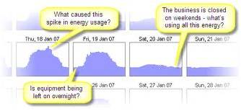Interval metering, Interval Data Recorders(IDR), is used to monitor the half-hour interval usage of electricity to determine demand. Dominion measures demand as the highest average kW measured in any 30-minute interval. See the specific rate schedule to determine the time periods used to determine the demand. These intervals start at the top of the hour, i.e. 0900 hrs and end at the bottom of the hour, i.e. 0930 hrs and start over again at the bottom of the hour, i.e. 0930 hrs for another 30-minute interval. As an example, if a 1,000 kW load was turned on at 1000 hrs and turned off at 1030 hrs, the highest average demand in this 30-minute interval would be 1,000 kW. If the 1,000 kW load was turned on at 1000 hrs and turned off at 1015 hrs, the highest average demand would be 500 kW. If the 1,000 kw load was turned on at 1015 hrs and kept on for 30 minutes until 1045 hrs, the highest average demand in a 30-minute interval would be 500 kW because the load was on in two 30-minute intervals. The IDR data can be used to plot energy usage on a 30-minute basis. This will show how loads vary.

Many meters are now read by Automatic Meter Reading (AMR). For many meters the meter reader no longer needs to walk up to each meter. The meter reader can now drive down the street and read the meters automatically without every getting out of the truck.

**ELECTRICITY TERMINOLOGY**

Some of the common terms used in the electric utility industry include:

* Voltage – Volts
* Current – Amps
* Resistance – Ohms
* Power – Watts
* Ohms Law
* kW – kilowatt
* kWh – kilowatt-hour
* Power Factor
* Load Factor
* kVA – kilovolt ampere
* rkVA – reactive kilovolt ampere
* CDD – Cooling Degree Day
* HDD – Heating Degree Day
* On-Peak Hours
* Off-Peak Hours

**Voltage**

* Volts is the electrical force that causes electrons (current) to flow
* Voltage can also be thought of as the electrical pressure that pushes electrons in a wire
* The unit of voltage is VOLTS (V)



**Current**

* Current is the flow of electrons
* The unit of current is AMPS (A)



**Resistance**

* Resistance is the electrical property of a substance to resist the flow of electrons
* The unit of resistance is OHMS (R)
* The larger the resistance, the more resistance to current flow



**Ohms Law**

* Volts = Current x Resistance
* V = A x R
* Units
* Volts is in volts
* Current is in amps
* Resistance is in ohms

**Power**

* P (watts) = A (amps) x V (volts)
* A (amps) = P (watts) / V (volts)

**KW**

* W (watt) x 1,000 = KW (kilowatt)
* Demand
* Rate at which energy is used

**KWH**

* KW (kilowatt) x Time (hours) = KWH (kilowatt – hour)
* Energy consumed over a period of time

**Terminology**

* On-Peak Hours – hours during which demand for electricity is usually higher and during which the utility may charge a higher rate
* Off-Peak Hours – any time that is not on-peak
* Load Factor – ratio of how much energy was used during a time period versus the maximum possible usage.
  + LF = kWh/(kW x 24 x Days)
* Power Factor = kW/kVA
* kVA - kilovolt ampere (transformer rating)
* rKVA – reactive kilovolt ampere
* Cooling Degree Days (CDD)
  + A measure of how much (in degrees), and for how long (in days), outside air temperature was *higher* than a specific base temperature. They are used for calculations relating to the energy consumption required to cool buildings.
* Heating Degree Days (HDD)
  + A measure of how much (in degrees), and for how long (in days), outside air temperature was *lower* than a specific "*base temperature*" (or "*balance point*"). They are used for calculations relating to the energy consumption required to heat buildings.